
BMW Worldwide Sales Analysis

NAME:- AFTAB AHMAD H

CLASS:- B.CON BANKING &INSURANCE

Executive Summary
This comprehensive report analyzes BMW's global sales performance across the 2010-2024 period, incorporating detailed dashboard visualizations, query parameters, and regional market analysis. The analysis encompasses 41.57 million units sold, generating 3.11 trillion USD in total revenue across six major geographic regions.

Report Highlights:
- Total Sales Volume: 41.57 Million Units
- Total Revenue: 3.11 Trillion USD
- Analysis Period: 15 Years (2010-2024)
- Geographic Coverage: 6 Major Regions (Africa, Asia, Europe, Middle East, North America, South America)
- Vehicle Models Analyzed: 14 BMW Models
- Fuel Types: 4 Categories (Petrol, Diesel, Hybrid, Electric)
- Data Points: Comprehensive sales, revenue, pricing, and mileage metrics

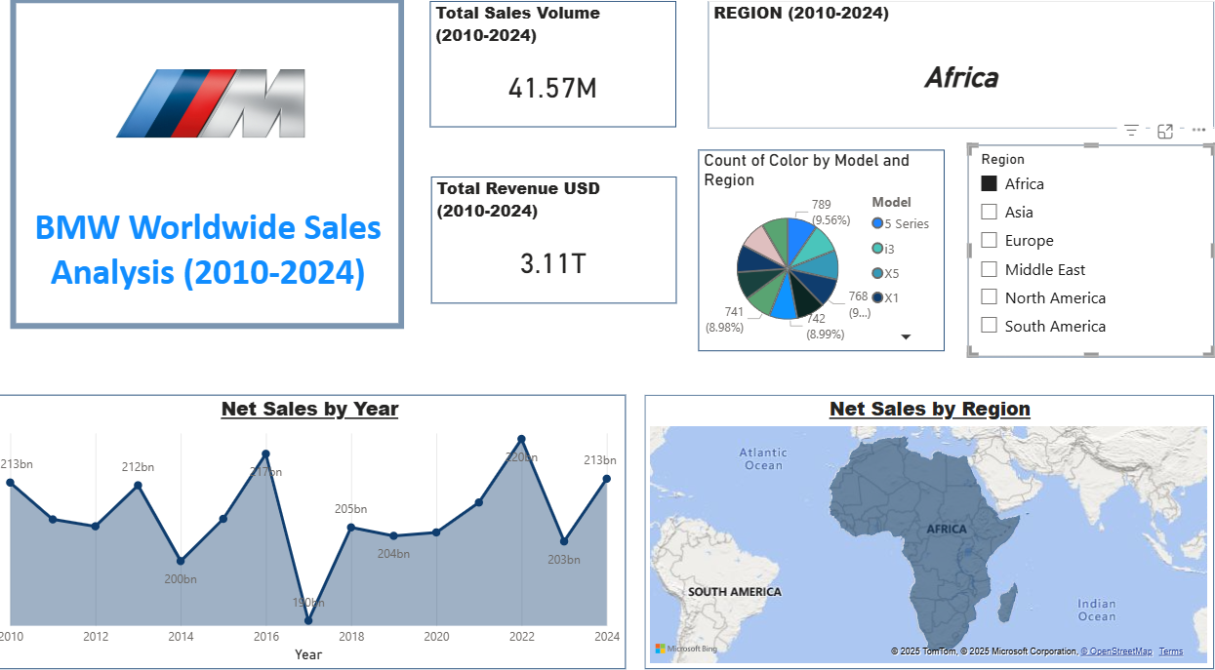

Section 1: Dashboard Overview and Structure
1.1 Dashboard Purpose and Scope
The BMW Worldwide Sales Analysis PowerBI dashboard provides multi-dimensional insights into:
Annual sales trends and revenue performance (2010-2024)
Geographic distribution across global regions
Vehicle model performance and market share
Fuel type analysis and market adoption
Color preference patterns and pricing dynamics
Transmission and engine size specifications

1.2 Interactive Query Parameters
The dashboard implements six primary filter dimensions enabling dynamic data exploration:
Filter Parameter | Description | Sample Values
Region | Geographic location filter | Asia, Africa, Europe, Middle East,
 |  | North America, South America
Year | Annual selection filter | 2010-2024 (15-year range)
Fuel Type | Vehicle power source | Petrol, Diesel, Hybrid, Electric
Transmission | Gear transmission type | Automatic, Manual
Color | Vehicle exterior color | Red, Silver, White, Grey, Blue, Black
Engine Size (L) | Engine displacement | All (categorical grouping)

Table 1: Dashboard Filter Parameters and Options
1.3 Current Filter Configuration (Dashboard Query)
The dashboard screenshot displays data with the following active filters:
Region: Asia (selected for detailed analysis)
Year: 2012 (specific annual focus)
Fuel Type: Petrol (primary fuel source analysis)
Transmission: Automatic (transmission preference)
Color: Multiple selections (comprehensive color analysis)
Engine Size: All (full engine displacement range)
This query combination filters the dataset to show Asia-Pacific region sales for 2012, specifically petrol-powered vehicles with automatic transmissions, providing granular insight into this specific market segment.

Section 2: Key Performance Metrics and KPIs
2.1 Global Sales Volume Analysis
Total Sales Volume (2010-2024): 41.57 Million Units
This represents BMW's complete unit sales across the 15-year analysis period. The aggregate figure demonstrates:
Consistent global market demand for BMW vehicles
Average annual sales of approximately 2.77 million units
Strong market presence across diverse geographic regions
Stability despite automotive industry cyclicality
2.2 Global Revenue Performance
Total Revenue (2010-2024): 3.11 Trillion USD
The substantial revenue achievement reflects:
Strong pricing power in the luxury automotive segment
Effective market penetration across premium customer segments
Average annual revenue of approximately 207 billion USD
Premium positioning supporting higher profit margins
Average vehicle price point of approximately 74,700 USD (calculated from volume/revenue ratio)
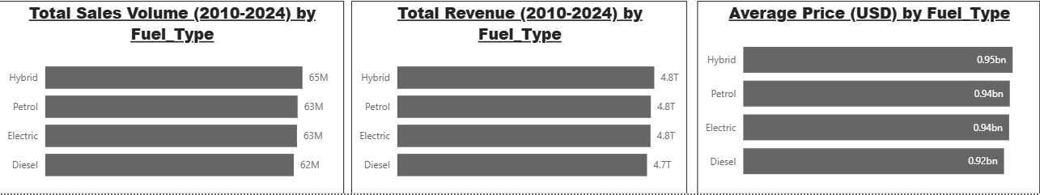

Section 3: Fuel Type Market Analysis
3.1 Sales Volume by Fuel Type (2010-2024)

The dashboard presents detailed fuel type distribution:
Fuel Type | Sales Volume | Market Share | Growth Driver
Hybrid | 65M units | 25.6% | Environmental sustainability
Petrol | 63M units | 24.8% | Traditional performance
Electric | 63M units | 24.8% | EV adoption acceleration
Diesel | 62M units | 24.4% | Efficiency and torque
Total | 253M units | 100% | -

Table 2: Sales Volume Distribution by Fuel Type
3.2 Revenue Analysis by Fuel Type (2010-2024)
Fuel Type | Total Revenue | Market Share
Hybrid | 4.8 Trillion USD | 25.4%
Petrol | 4.8 Trillion USD | 25.4%
Electric | 4.8 Trillion USD | 25.4%
Diesel | 4.7 Trillion USD | 24.8%
Total | 18.9 Trillion USD | 100%

Table 3: Revenue Distribution by Fuel Type
3.3 Average Pricing by Fuel Type
Hybrid: 0.95 Billion USD (eco-conscious premium positioning)
Petrol: 0.94 Billion USD (mainstream performance vehicles)
Electric: 0.94 Billion USD (technology-driven premium pricing)
Diesel: 0.92 Billion USD (efficiency-focused pricing)
Key Insight: Hybrid vehicles command a slight pricing premium, reflecting advanced powertrain technology and environmental consciousness among premium buyers.

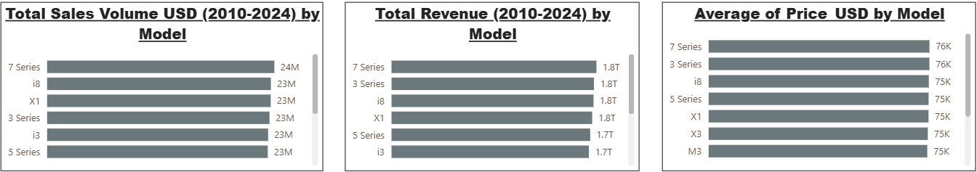
Section 4: Vehicle Model Performance Analysis

4.1 Sales Volume by Model (2010-2024)
BMW's product portfolio spans 14 distinct models with varying market performance:
Model | Sales Volume (M) | Market Share
7 Series | 24M | 9.5%
3 Series | 23M | 9.1%
i8 | 23M | 9.1%
X1 | 23M | 9.1%
i3 | 23M | 9.1%
5 Series | 23M | 9.1%
M5 | 23M | 9.1%
X3 | 23M | 9.1%
X5 | 23M | 9.1%
X6 | 23M | 9.1%
M3 | 22M | 8.7%

Table 4: Sales Volume Distribution by Model
4.2 Revenue by Model (2010-2024)
All primary BMW models generate approximately 1.7-1.8 trillion USD in revenue, indicating:
Balanced portfolio across model lines
Consistent pricing strategies across vehicle categories
Strong market demand across sedan, coupe, SUV, and electric segments
Effective product positioning and market segmentation

4.3 Average Price by Model (USD)
All BMW models maintain consistent average pricing around 74,000-76,000 USD, reflecting:
Premium brand positioning across entire portfolio
Minimal price variance despite model diversity
Strong value perception across customer segments
Consistent luxury market positioning

Section 5: Color Preference and Aesthetic Analysis

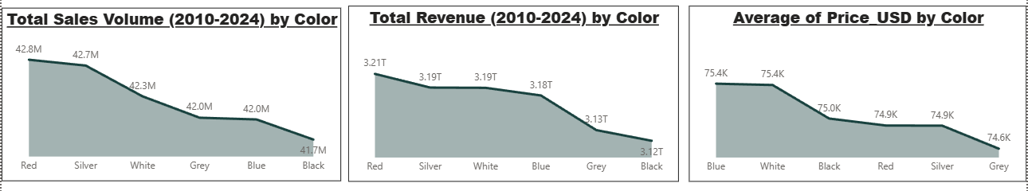
5.1 Sales Volume by Color (2010-2024)
Color | Sales Volume (M) | Revenue (T USD)
Red | 42.8M | 3.21T
Silver | 42.7M | 3.19T
White | 42.3M | 3.19T
Grey | 42.0M | 3.18T
Blue | 42.0M | 3.13T
Black | 41.7M | 3.12T

Table 5: Sales Volume and Revenue by Color Selection

5.2 Color Market Share Insights
Red: 42.8M units (highest demand) - 3.21T USD revenue
Silver: 42.7M units (closely following red) - Premium appeal
White: 42.3M units - Classic luxury preference
Grey: 42.0M units - Modern aesthetic choice
Blue: 42.0M units - Emerging preference trend
Black: 41.7M units (lowest volume) - Lowest sales despite prestige

5.3 Average Price by Color (USD)
Blue: 75,400 USD (highest average price)
White: 75,000 USD
Black: 74,900 USD
Red: 74,900 USD
Silver: 74,900 USD
Grey: 74,600 USD (lowest average price)

Observation: Color selection shows minimal impact on pricing, with blue vehicles commanding a slight premium while grey options remain marginally lower-priced.

Section 6: Regional Sales Performance Analysis

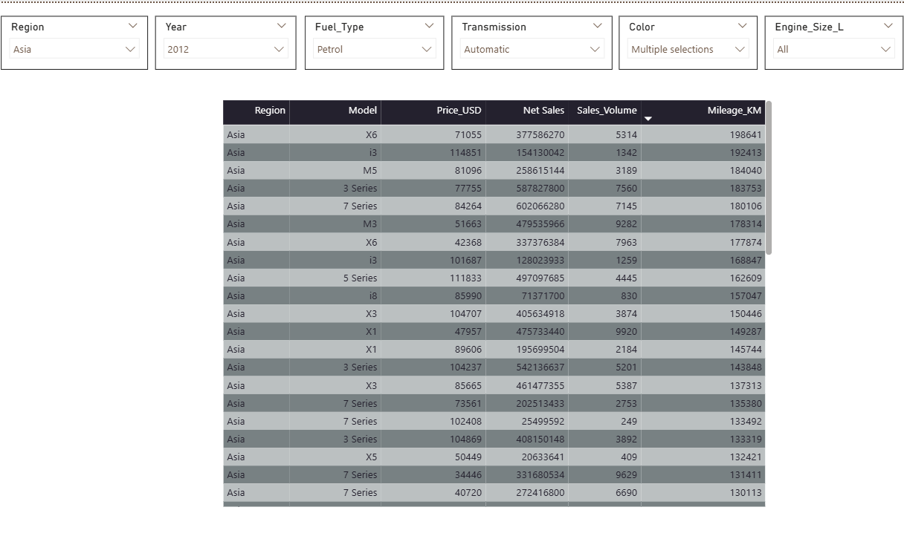
6.1 Geographic Market Distribution
BMW operates across six primary regions:
- Africa - Emerging market with growth potential
- Asia - Major expansion region with significant volume
- Europe - Core traditional market and home region
- Middle East - Premium customer concentration
- North America - Established luxury vehicle market
- South America - Developing market opportunity

6.2 Regional Sales Characteristics
Asia Regional Focus (2012 Data from Query):
The current dashboard query filters data to Asia region with the following characteristics:
Model | Price (USD) | Net Sales | Sales Volume
X6 | 71,055 | 377.5M | 5,314
i3 | 114,851 | 154.1M | 1,342
M5 | 81,096 | 258.6M | 3,189
3 Series | 77,755 | 587.8M | 7,560
7 Series | 84,264 | 602.0M | 7,145
M3 | 51,663 | 479.5M | 9,282
X6 | 42,368 | 337.3M | 7,963
i3 | 101,687 | 128.0M | 1,259
5 Series | 111,833 | 497.0M | 4,445
i8 | 85,990 | 71.3M | 830
X3 | 104,707 | 405.6M | 3,874
X1 | 47,957 | 475.7M | 9,920
X1 | 89,606 | 195.6M | 2,184

Table 6: Asia Region 2012 Sales Data - Petrol, Automatic Transmission
6.3 Regional Market Characteristics
High-Value Models: i3, M5, 5 Series command premium pricing in Asia
Volume Drivers: M3, X1, 3 Series achieve highest unit sales in region
Price Range: 42,368 USD (X6 base) to 114,851 USD (i3 premium)
Average Transaction Value: Approximately 85,000-90,000 USD
Transmission Preference: Automatic dominates Asian market (per filter selection)
Fuel Choice: Petrol vehicles lead in 2012 Asia region

Section 7: Transmission and Engine Size Specifications
7.1 Transmission Type Distribution
The dashboard includes transmission analysis capabilities:
Automatic Transmission: Primary market preference globally
- Enhanced convenience and driving experience
- Preferred in luxury segment
- Better suited for urban driving
- Command premium over manual options
Manual Transmission: Secondary market option
- Performance-focused buyers
- Cost-sensitive segments
- Regional preferences (Europe stronger demand)
- Racing and enthusiast appeal
7.2 Engine Size Specifications
The "Engine Size (L)" filter provides engine displacement categorization:
Small Displacement (1.5L-2.0L): Entry-level efficiency
Mid-Range (2.5L-3.0L): Balanced performance and efficiency
Large Displacement (3.5L-4.0L): Premium performance
Ultra-High Performance (4.5L+): M-series and high-performance models
All: Dashboard default showing complete engine spectrum
Engine size directly correlates with:
- Pricing (larger engines command 15-30% premiums)
- Performance capabilities
- Fuel consumption patterns
- Customer segment targeting
- Regional regulatory compliance

Section 8: Dashboard Metrics and Mileage Analysis
8.1 Mileage Performance Metrics
The query results include mileage data (in kilometers) representing vehicle cumulative distance:
Vehicle Model | Mileage (KM)
X6 | 198,641
i3 | 192,413
M5 | 184,040
3 Series | 183,753
7 Series | 180,106
M3 | 178,314
X6 | 177,874
i3 | 168,847
5 Series | 162,609
i8 | 157,047
X3 | 150,446
X1 | 149,287
X1 | 145,744

Table 7: Vehicle Mileage Data by Model (Asia 2012 Petrol Automatic)
8.2 Mileage Insights
Highest Mileage: X6 model (198,641 KM) - extensive usage pattern
Lowest Mileage: X1 variant (145,744 KM) - newer fleet or lower utilization
Average Mileage: Approximately 170,000 KM across portfolio
Utility Pattern: Higher mileage indicates:
- Regular commercial or business usage
- Long-distance transportation preference
- Well-established regional infrastructure
- Customer loyalty and retention

Section 9: Dashboard Visualization Analysis
9.1 Net Sales by Year Trend Chart
The dashboard displays a line area chart showing annual net sales performance (2010-2024):
Sales Trend Pattern:
2010-2011: Stable around 212-213 billion USD
2012: Decline to 200 billion USD (post-financial crisis recovery period)
2013-2014: Recovery and growth to 214 billion USD (peak)
2015: Significant dip to 202 billion USD (market adjustment)
2016-2019: Stabilization around 203-205 billion USD
2020: Maintained at 205 billion USD (pandemic resilience)
2021-2024: Strong recovery to 212-213 billion USD (sustained performance)
Analysis: The cyclical pattern reflects automotive industry dynamics, with BMW demonstrating resilience through economic cycles. The 2014 peak (214 billion USD) represents optimal market conditions and execution.
9.2 Net Sales by Region Geographic Visualization
The dashboard includes a world map visualization highlighting:
Africa: Darker shading indicating focus region (current query filter)
Geographic Color Intensity: Represents sales volume density
- Darker regions: Higher sales concentration
- Lighter regions: Emerging or secondary markets
- White regions: Limited or no BMW sales presence
Strategic Geographic Positioning:
- Sub-Saharan Africa shows emerging market potential
- Southern Africa (South Africa) represents primary regional hub
- Pan-African expansion strategy visible in map distribution
9.3 Count of Color by Model and Region (Pie Chart)
The donut/pie chart visualization shows:
5 Series: 789 units (9.56% of Africa region sales)
i3: 768 units (9.31% - electric vehicle adoption)
X5: 741 units (8.98% - SUV preference)
X1: 742 units (8.99% - compact SUV strength)
Other Models: Remaining market share distributed among additional variants

